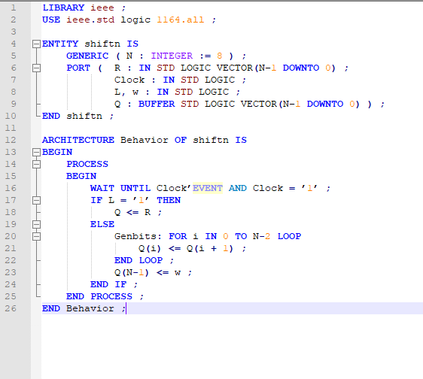

LIBRARY ieee;

USE ieee.std_logic_1164.ALL;

USE ieee.std_logic_unsigned.ALL;

-----------------------------------------------------------------------------

-- ENTITY: Problem8

-----------------------------------------------------------------------------

ENTITY Problem8 IS

PORT (

Resetn : IN STD_LOGIC;

FWD : IN STD_LOGIC;

Clock : IN STD_LOGIC;

Q : OUT std_logic_vector(2 downto 0)

);

END Problem8;

-----------------------------------------------------------------------------

-- ARCHITECTURE: behav

-- This architecture is implemented with behavioural VHDL

-----------------------------------------------------------------------------

ARCHITECTURE behav OF Problem8 IS

-- This area is used to define types and any internal signals

signal Count : std_logic_vector(2 downto 0);

begin

process (Clock, Resetn)

begin

if (Resetn = '0') then

Count <= "000";

elsif (Clock' EVENT AND Clock = '1') then

if (FWD = '1')then

Count <= Count + 1;

elsif (FWD = '0') then

Count <= Count - 1;

end if;

end if;

end process;

process (Count) is

BEGIN

CASE Count IS

WHEN "000" => Q <= "101" ; -- drive Q to 5

WHEN "001" => Q <= "110" ; -- drive Q to 6

WHEN "010" => Q <= "111" ; -- drive Q to 7

WHEN "011" => Q <= "000" ; -- drive Q to 0

WHEN "100" => Q <= "001" ; -- drive Q to 2

WHEN "101" => Q <= "100" ; -- drive Q to 4

WHEN "110" => Q <= "011" ; -- drive Q to 3

WHEN "111" => Q <= "001" ; -- drive Q to 1

END CASE;

end process;

END behav;

0: 5, 6, 7, 0, 2, 4, 3, 1

